===================================

Assign a Name to the Host Device



===================================

Configure passwords

**Securing user EXEC mode access:**



**Securing privileged EXEC mode access:**



**Securing VTY line access:**

PC0> **telnet** *Sw-Floor-1-ip*



===================================

Save Configurations

**Configuration Files:**

To save changes made to the running configuration to the startup configuration file, use: **copy running-config startup-config**



===================================

**Switch Virtual Interface Configuration:**

IP is assigned to switch as a whole object, not in a specific port.

VLAN is a virtual port. By default, all interfaces of a switch fall under the default VLAN 1.

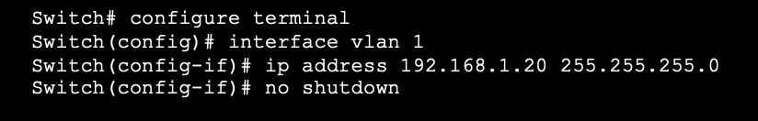

===================================

Configure Initial Router Settings

**Basic Router Configuration Example:**

R1(config)# **hostname R1**

R1(config)# **enable secret class**

R1(config)# **line console 0**

R1(config-line)# **password cisco**

R1(config-line)# **login**

R1**(**config-line)# **line vty 0 4**

R1(config-line)# **password cisco**

R1(config-line)# **login**

R1(config-line)# **exit**

R1(config)# **service password encryption**

R1(config)# **banner motd #** *message* **#**  
R1(config)# **exit**

R1# **copy running-config startup-config**

===================================

Configure Interfaces

**Configure Router Interfaces:**

Router(config)# **interface** *type-a-number*  
Router(config-if)# **description** *description-text*  
Router(config-if)# **ip address** *ipv4-address subnet-mask*  
Router(config-if)# **no shutdown**

**For Serial port [ONLY in the router with the ‘clock’ sign]:**

**int Se0/0**

**ip address 100.1.1.1 255.255.252.0**

**clock rate 64000**

**no shutdown**

**Setting the default gateway**

SW1(config)# **ip default-gateway 172.16.1.1**

**Verify Interface Configuration:**

R1# **show ip interface brief**

Interface IP-Address OK? Method Status Protocol

GigabitEthernet0/0/0 192.168.10.1 YES manual up up

GigabitEthernet0/0/1 209.165.200.225 YES manual up up

Vlan1 unassigned YES unset administratively down down

**Configure Verification Commands:**

**show interfaces** Displays statistics for all interfaces on the device. Only displays the IPv4 addressing information.

**show ip interfaces** Displays the IPv4 statistics for all interfaces on a router.

===================================

VLAN Config

**Overview of VLANs:**

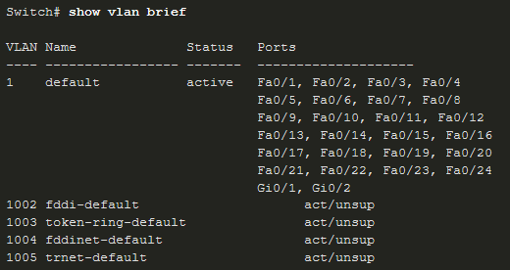

**VLAN Creation [in all switches/routers]:**

Switch# **conf t**

Switch(config)# **VLAN 10**

Switch(config-vlan)# **name CSE**

Switch(config)# **VLAN 20**

Switch(config-vlan)# **name ME**

**VLAN Port Assignment Commands [in all switches/routers]:**

Switch# **conf t**

Switch(config)# **int fa0/1**

Switch(config-if)# **switchport mode access**

Switch(config-if)# **switchport access vlan 10**

Switch(config)# **int fa1/1**

Switch(config-if)# **switchport mode access**

Switch(config-if)# **switchport access vlan 20**

**Verify VLAN info:**

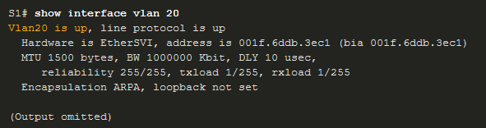

**Lists information about the VLANs:**

SW1# **show vlan** {**brief** | *id* | *name* | **summary**}

**Place interface back in VLAN 1:**

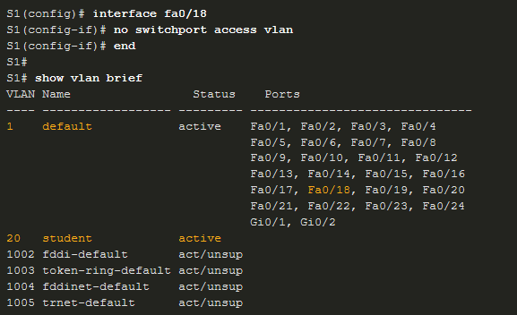

**Delete VLANs:**

Delete VLANs with the **no vlan** *vlan-id*

**Caution**: Before deleting a VLAN, reassign all member ports to a different VLAN.

* Delete all VLANs with the **delete flash:vlan.dat** or **delete vlan.dat** commands.
* Reload the switch when deleting all VLANs.

===================================

VLAN Trunks

**Trunk Configuration Commands [in all switches/routers]:** 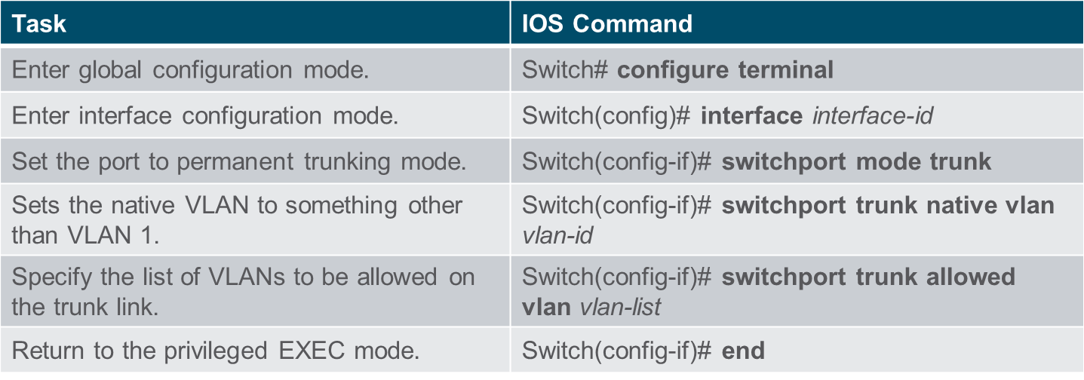

**int g0/1**

**switchport mode trunk**

**switchport trunk native vlan 1**

**switchport trunk allowed vlan 10,20,1**

**Verify Trunk Configuration:**

Switch# **show int fa0/1 switchport**

**Lists all the trunk ports on a switch including the trunk allowed VLANs:**

SW1# **show interfaces trunk**

===================================

Inter-VLAN Routing

**Configure Legacy Inter-VLAN Routing::**

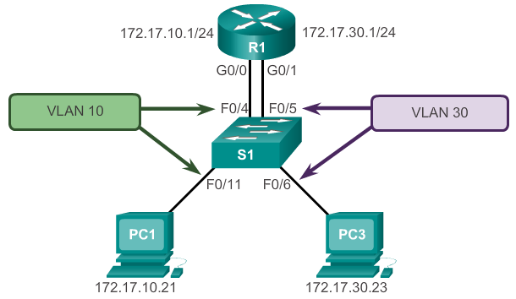

**Switch configuration:**

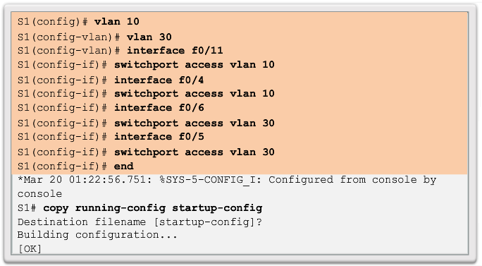

**Router Interface Configuration:**

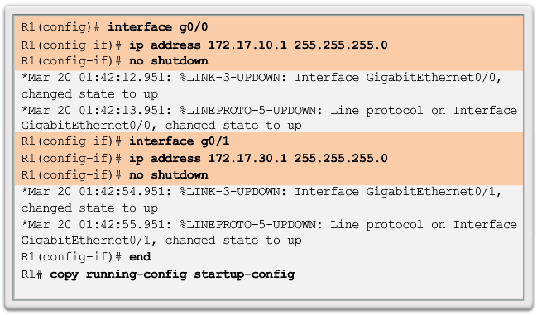

**Configure Router-on-a-Stick::**

**Switch:**

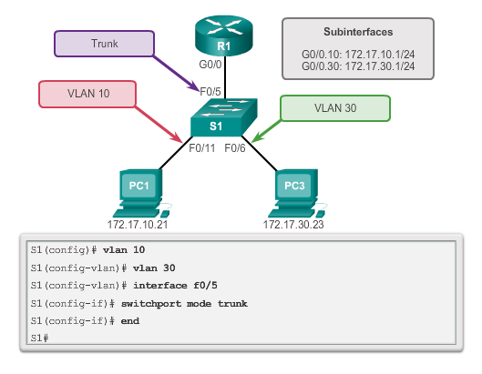

**Router:**

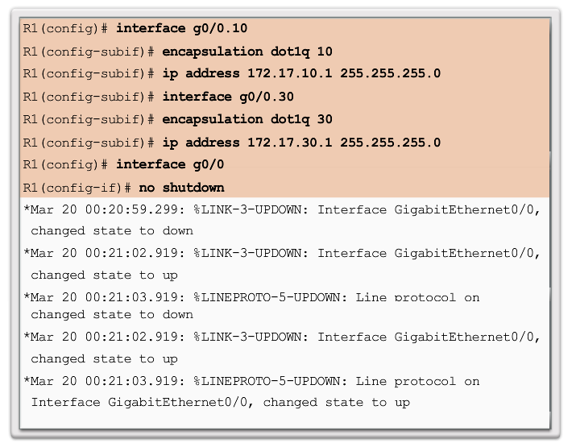

===================================

Routing

**Static Default Routing [In BOTH NAT router and external router]:**

**ip route 0.0.0.0 0.0.0.0 Se0/0**

[If this router doesn’t recognize any destination address, it directs the traffic to Se0/0 interface]

**Static Routing:**

**ip route** *network-address-that-is-not-neighbor-of-this-router* *subnet-mask* *interface-to-reach-that-network-from-this-router*

R1# **show ip route static** Shows routes learned via static routing only

**Dynamic Routing:**

**router rip**

**network** *network-address-that-is-neighbor-of-this-router*

**show ip route** Displays the contents of the IP routing tables stored in RAM.

R1# **show ip route rip** Shows routes learned via RIP only

===================================

ACL [ACL rules per interface => inbound, outbound (From Router’s perspective); An ACL must have at least one permit statement otherwise all traffic will be denied due to the implicit deny ACE statement.]

**Standard ACL [Closest to destination; Source IP, Wildcard-mask]::**

**Configure Numbered Standard IPv4 ACL [In config mode]:**

**ip access-list 10 permit 192.168.10.64 0.0.0.15** [192.168.10.64 to 192.168.10.79]

**ip access-list 10 deny any** (default)

**ip access-list 10 permit host 192.168.10.10** [host means ‘0.0.0.0’; so this list permits ONLY the device with ip 192.168.10.10]

**ip access-list 10 deny 192.168.10.0 0.0.0.255**

[and denies all other ips]

**int g0/0**

**ip access-group 10 in**

**Configure Named Standard IPv4 ACL[In config mode]:**

**ip access-list standard PERMIT-ACCESS**

**permit host 192.168.10.10**

**deny 192.168.10.0 0.0.0.255**

**int s0/0**

**ip access-group PERMIT-ACCESS out**

**Permit / Deny All IP:**

R1(config-ext-nacl)# **permit any** [permit all except the ones denied with ‘deny’ command]

**Extended ACL[Closest to source; Protocol, Src IP, Wildcard-mask, Dest IP, Wildcard-mask, Port]:**

**Configure Extended ACLs [Named]:**

R1(config)# **ip access-list extended FTP-FILTER**

R1(config-ext-nacl)# **permit tcp 192.168.10.0 0.0.0.255 any eq ftp**

R1(config-ext-nacl)# **permit tcp 192.168.10.0 0.0.0.255 any eq ftp-data**

R1(config-ext-nacl)# **permit tcp 192.168.10.0 0.0.0.255 any eq www**

[permit any device from network 192.168.10.0 to connect to any destination IP with ports ftp,ftp-data,www]

R1(config-ext-nacl)# **permit tcp 192.168.10.0 0.0.0.255 host 100.100.100.3 eq ftp**

[permit any device from network 192.168.10.0 to connect to the device 100.100.100.3 with port ftp]

**int s0/1**

**ip access-group FTP-FILTER out**

**Permit / Deny All IP:**

R1(config-ext-nacl)# **permit ip any any** [permit all except the ones denied with ‘deny’ command]

R1(config-ext-nacl)# **deny ip any any** [default]

**Configure Extended ACLs [Numbered]:**

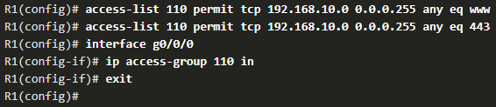

**Delete an ACL::**

**In Config Mode:**

**no ip access-list extended FTP-FILTER** Extended ACL

**no ip access-list standard PERMIT-ACCESS** Standard ACL

**no access-list 10** Both

**In Interface Mode [Both extended and standard]:**

**int s0/0**

**no ip access-group FILTER out**

**Verify ACL:**

R1# **show access-lists**

R1# **show ip access-list** Shows all ACLs configured on a router with counters at the end of each statement

R1# **show ip access-list 101** Shows only the specified ACL

R1# **show ip interface g0/0** verify the ACL on the interface and the direction in which it was applied.

===================================

Static NAT

**Configure Static NAT [In NAT router]:**

R2(config)# **ip nat inside source static 192.168.10.254 209.165.201.5**

R2(config)#

R2(config)# **interface serial 0/1/0**

R2(config-if)# **ip address 192.168.1.2 255.255.255.252**

R2(config-if)# **ip nat inside**

R2(config-if)# **exit**

R2(config)# **interface serial 0/1/1**

R2(config-if)# **ip address 209.165.200.1 255.255.255.252**

R2(config-if)# **ip nat outside**

Verify Static NAT [In NAT router]:

R2# **show ip nat translations**

R2# **show ip nat translations**

Pro Inside global Inside local Outside local Outside global

--- 209.165.201.5 192.168.10.254 --- ---

Total number of translations: 1

R2# **show ip nat statistics**

Total active translations: 1 (1 static, 0 dynamic; 0 extended)

Outside interfaces:

Serial0/1/1

Inside interfaces:

Serial0/1/0

Hits: 4 Misses: 1

(output omitted)

===================================

Dynamic NAT

**Configure Dynamic NAT [In NAT router]:**



**Clear Dynamic Translation Entry:**

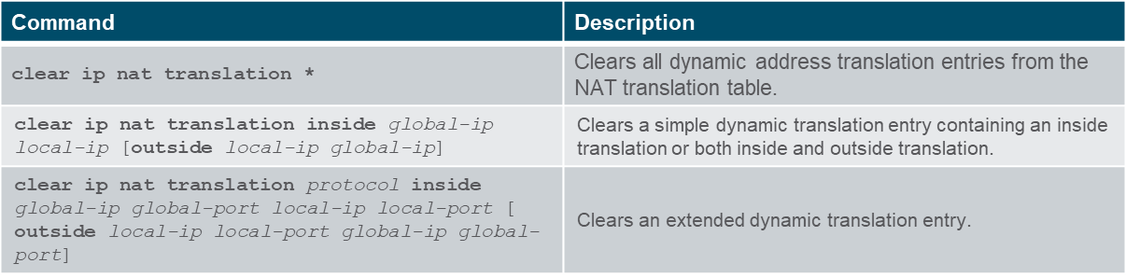

===================================

PAT

**Configure PAT to Use a Single IPv4 Address [previous ACL 1 is used]:**

R2(config)# **ip nat inside source list 1 209.165.200.225 overload**

R2(config)# **access-list 1 permit 192.168.0.0 0.0.255.255**

R2(config)# **interface serial0/1/0**

R2(config-if)# **ip nat inside**

R2(config-if)# **exit**

R2(config)# **interface Serial0/1/1**

R2(config-if)# **ip nat outside**

**Configure PAT to Use an Address Pool:**

R2(config)# ip nat pool NAT-POOL2 209.165.200.226 209.165.200.240 netmask 255.255.255.224

R2(config)# access-list 1 permit 192.168.0.0 0.0.255.255

R2(config)# ip nat inside source list 1 pool NAT-POOL2 overload

R2(config)# interface serial0/1/0

R2(config-if)# ip nat inside

R2(config-if)# interface serial0/1/0

R2(config-if)# ip nat outside

**Verify PAT:**

R2# **show ip nat translations**